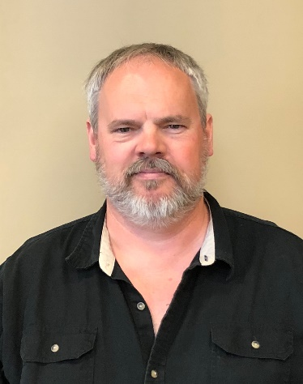
As District 1 Director, Jim Marshall comes from rural Mahaska County. It is here he resides on 17 acres with his wife, Tina. On this hobby farm, bordered by the Des Moines River, the two have raised 4 children, several flocks of 4-H chickens, and dozens of honeybee hives. This and more keeps Jim busy during the evenings and weekends, but during the day Jim is a custom project engineer overseeing hard numbers and major structural projects. This is one of the reasons Jim particularly enjoys being a beekeeper. Opening a hive provides such a sensory experience, you can forget about work and your worries. Jim can recall vivid memories growing up of stories about his Great Grandpa being a beekeeper in his vineyards in Italy then later in Numa, Ia when he immigrated to the USA, and saw first-hand his Uncle's hives in rural Appanoose County. Since then he has aspired to “someday” become a beekeeper himself. In 2010, his two oldest children were intrigued by the hobby and pursued, applied for, and received scholarship hives from their local Back to Basics Beekeeping Club. In this adventure to pursue a new hobby is where the family became all-in on the idea of keeping the bees, all the while experiencing the greatest reward – sweet honey for their own table. Since that time in 2010, the whole family has actively participated in the local bee club, state events, hosting school field trips, speaking to community groups, rescuing cut-outs and unwanted swarms, teaching Beekeeping 101 classes, and advocating for honeybee needs. Jim Marshall is a result of why we do Youth Beekeeping Scholarships. By committing to a youth, the resources to become a beekeeper, you have in fact activated a whole family, added to your membership and leadership, and educated and influenced a vast community on the importance of the honeybee.

