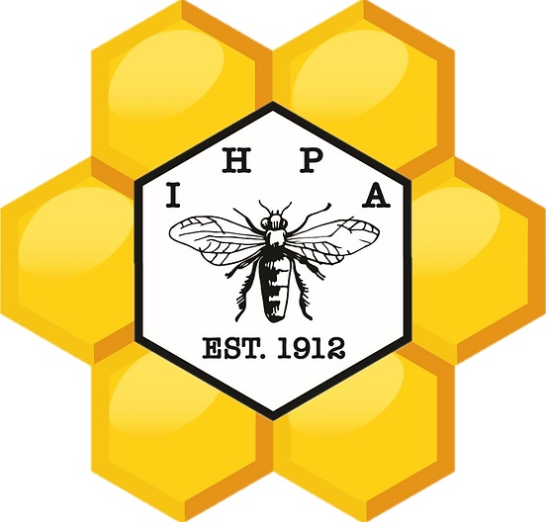
IOWA HONEY PRODUCERS
ASSOCIATION
MEMORIAL SCHOLARSHIP

BACKGROUND INFORMATION

This scholarship has been developed to honor several association members who are no longer with us but live on in the work we do to support and promote the importance of honey bees. Their dedication and hard work has made it possible for us to be a successful organization for over 100 years!!!

TO THE APPLICANT:
There is a recipient selected from each of the six districts in our state. That deserving student will receive $500 after the successful completion of their first semester. If you do not know which district you belong to, or the directors to contact if you are interested in more information about the IHPA, a map of the districts and their directors are available on the IHPA Website at: https://www.iowahoneyproducers.org

Before completing this application, read the informational page which specifies the criteria for both eligibility and selection. Since the members of the Scholarship Committee haven't met you, carefully consider the content and completeness of your responses to the information being sought.

Additional pages of narrative or supporting documentation can be added to any section. This may include copies of newspaper clippings, photos, letters of recommendation from people within your school and/or community, and other materials which will give the committee a better insight about you, your school, and your community activities. PLEASE MAKE COPIES. These materials will not be returned.

SECTION III MUST BE IN YOUR OWN HANDWRITING. Be certain your handwriting is LEGIBLE.

Also, you must SIGN and DATE your application in order for it to be considered complete and valid.

This application must be postmarked no later than: February 1, 2023

All applications and correspondence should be sent to the:

Iowa Honey Producers Association
Scholarship Selection Committee
℅ Dick Ostercamp or Roy Kraft
15920 Hickman Road
Ste 400 PM446
Clive, Iowa 50325

- Identification Data (use pen)

Name_____________________________________________
First Middle Last

Address___________________________________________

_____________________ ________________ __________
City State ZIP Code

_________________________________
Telephone # with Area Code

Email address_______________________________________

High School Name___________________________________

High School Address_________________________________

_____________________ ________________ __________
City State ZIP Code

____________________________
Telephone # with Area Code

Graduation Date_____________________________________
Month Year

- Academic Record

Grade Point Average_____________ Rank in Class_______
ACT Score (if taken)______________ Date Taken_________
SAT Score (if taken)______________ Date Taken_________
Date when above information was compiled________________

Attach (or forward under separate cover) a current certified transcript of your credits signed by a school official and embossed with official seal by February 1, 2023. If your school does not provide certified transcripts until after graduation, the transcript must be sent directly by the school with a letter stating the school policy.

Students who are homeschooled are encouraged to apply as well !!! (Documentation will be required)

- Personal Resume

You must complete this section in your own handwriting. Write about yourself, your home, family, interests and your future education or vocational plans. How does beekeeping, or your knowledge of the importance of pollination, fit into your future plans? This will give the committee the best picture of you as an individual (2 page minimum). Brag about yourself !!!

- School Activities

List those high school activities in which you have participated in and what leadership position you may have held. Indicate the grade (9,10,11,12) you participated in those activities as well. Describe any interesting things you were able to do while taking part in these activities.

- Community Service

Describe the ways in which you, a volunteer, have been of service to your community in general and/or to certain people in your community in particular. This service may have been performed as a member of an organization and/or on your own as an individual. Indicate any leadership roles you may have had in this area.

Members of the Iowa Honey Producers and the selection committee look forward to hearing from you and reading your stories.

