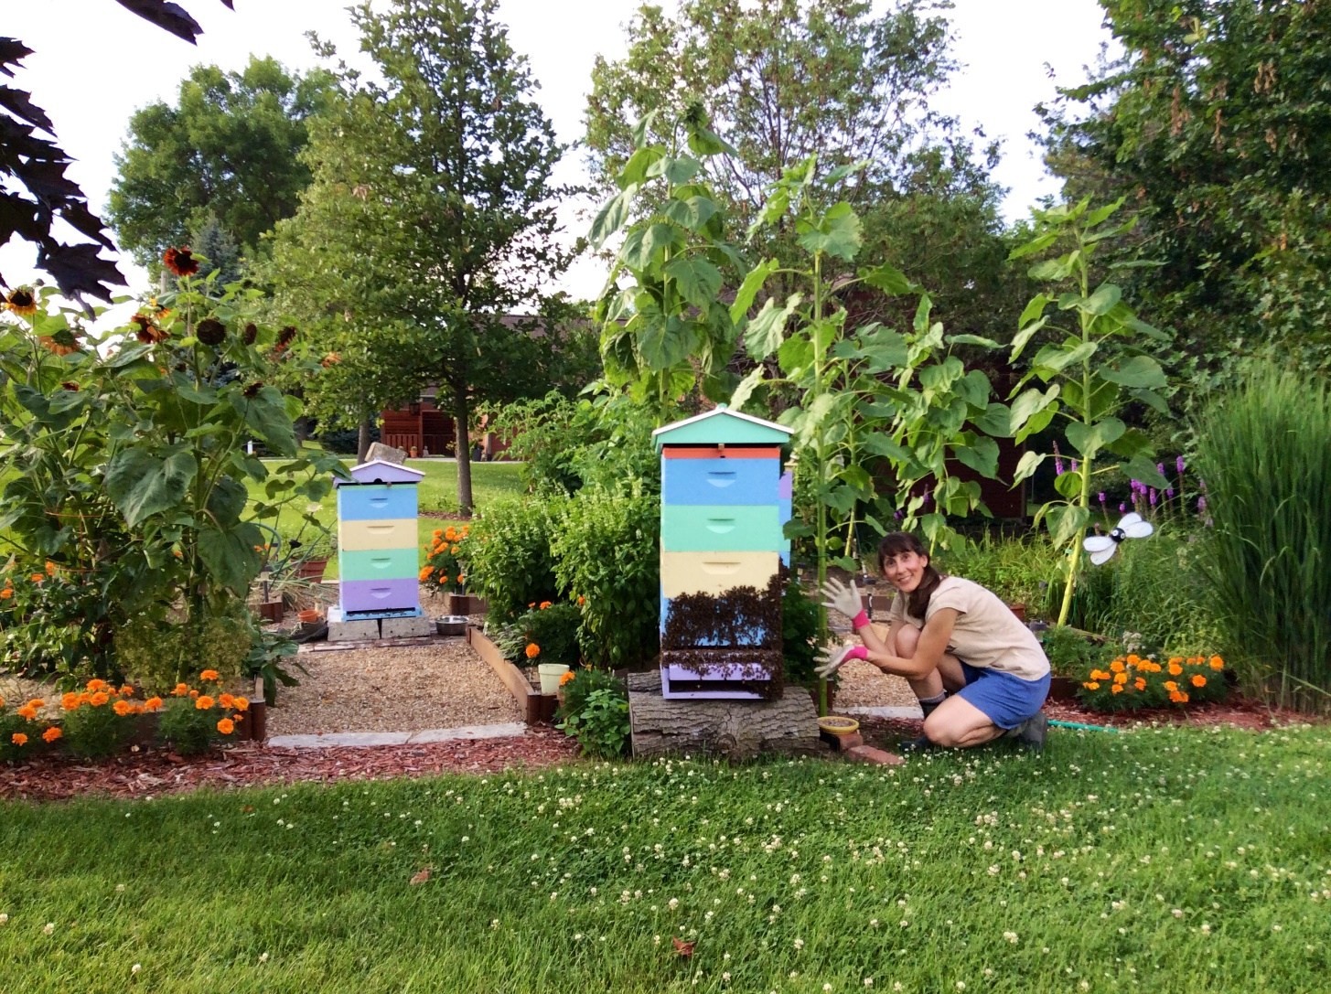

In 2005 Eve listened to a radio interview of Holly Bishop, author of the book Robbing the Bees, and was instantly captivated by the topic – and the book. It wasn’t until the winter of 2010 that she pursued the interest by taking a 9-week course on beekeeping. That April, on a cold and rainy day, she successfully installed her first two packages of bees without sustaining a single sting. Today, she and her husband Theo have 25 hives on their property outside Pella and two out yards selling honey out of their home. Eve is active with the Back to Basics Beekeeping Club in Oskaloosa and has volunteered at the Iowa Honey Producers Association booth at the Iowa State Fair, and at the honey booth at the Southern Iowa Fair. A Master Gardener since 2004 and past president of the Russ O’Harra Hosta Society, this passionate beekeeper is not afraid to get her hands dirty and is just as proud of her bees as she is her compost.

